Elections Updates 7/25

Uniqueness

Clinton Winning- Close

FiveThirtyEight’s Now Cast has Trump at 236 electoral votes and Clinton at 301.5---Trump only needs 34 more votes for a majority
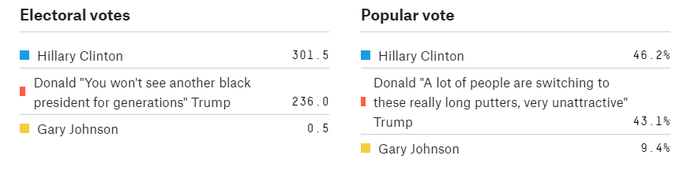
Silver 7/22/16 (Nate Silver is the founder and editor in chief of FiveThirtyEight; “Who Will Win the Presidency”; Now-cast is a projection of what would happen in a hypothetical election held today; you can find the polling/forcasting methodology and procedures at http://fivethirtyeight.com/features/a-users-guide-to-fivethirtyeights-2016-general-election-forecast/; find the predictions of the election at http://projects.fivethirtyeight.com/2016-election-forecast/#now)//hbuz
The now-cast is basically the polls-only model, except that we lie to our computer and tell it the election is today. As a result, the now-cast is very aggressive. It’s much more confident than polls-plus or polls-only; it weights recent polls more heavily and is more aggressive in calculating a trend line. There could be some big differences around the conventions. The polls-only and polls-plus models discount polls taken just after the conventions, whereas the now-cast will work to quickly capture the convention bounce.

Clinton winning now but Trump could still pull ahead – polling is not always accurate
Katz 7/19/16
(Josh, Journalist for the Upshot, “Hillary Clinton has a 76 Percent Chance to Win the Presidency” http://www.nytimes.com/2016/07/20/upshot/hillary-clinton-has-a-76-percent-chance-to-win-the-presidency.html?_r=0 - KSA)
For now, at least, Hillary Clinton has a 76 percent chance of defeating Donald Trump to become president of the United States. A victory by Mr. Trump remains quite possible: Mrs. Clinton’s chance of losing is about the same probability that an N.B.A. player will miss a free throw. This electoral probability, the first forecast by the Upshot’s presidential prediction model, is based on the voting history of each state and on roughly 300 state and national polls of the race conducted since mid-April. Our model suggests Mrs. Clinton is a strong favorite in 14 states and the District of Columbia, enough to give her 186 of the 270 electoral votes she needs to win the White House. Add to this eight more states that polls currently show are leaning Democratic — including Minnesota, Michigan and Pennsylvania — and Mrs. Clinton would have 275 electoral votes and the presidency. But, with 16 weeks remaining in the campaign, a lot can change. Using the same model, we would have said that Bill Clinton had less than a 20 percent chance to win the presidency with roughly four months to go in 1992. It was only after Ross Perot left the race and the Democrats rallied around Mr. Clinton after the Democratic convention that his polls improved. And they improved sharply. One month later, he was an 84 percent favorite. This kind of polling volatility should be expected, particularly with party conventions at hand. It is one reason that Mrs. Clinton’s probability of victory is not higher. Current polling averages suggest a four-point victory in the national popular vote for Mrs. Clinton, if nothing changes. But we expect changes between now and Election Day. The Upshot is not the only news organization trying to forecast election results. We believe each model provides useful glimpses of possible futures, so we are compiling forecasts from a variety of them into one easy-to-digest table. Viewed side by side, the differences among the models become clearer. Arizona, for example, is rated as a tossup by FiveThirtyEight, while our model has not yet seen enough polling evidence to revise its assessment of Arizona’s recent history as a Republican-leaning state. Similarly, while the betting markets rate New Mexico as almost a sure thing in the Democratic column, our model is not as certain, giving Mr. Trump a 21 percent chance to upset Mrs. Clinton there.

Hillary’s only up by 3 or 4 points going into the conventions---this historically leads to toss-ups
Silver 7/19/16 (Nate Silver is the founder and editor in chief of FiveThirtyEight; “Election Update: Clinton’s Lead Is As Safe As Kerry’s Was In 2004”; fivethirtyeight; http://fivethirtyeight.com/features/election-update-clintons-lead-is-as-safe-as-kerrys-was-in-2004/)//huz
There has been a lot of polling over the past few days in advance of the Republican National Convention, which got underway Monday in Cleveland. But it mostly confirmed the conclusion our election forecast models had arrived at late last week: Hillary Clinton leads Donald Trump by 3 or 4 percentage points. That’s down from a lead of 6 or 7 percentage points a few weeks ago. As a result, Donald Trump’s odds have improved. He has a 36 percent chance of winning the election, according to our polls-only forecast, and a 38 percent chance according to polls-plus. (While the polls-only and polls-plus forecasts are well aligned now, they may begin to diverge during the conventions — more about that in a moment.) But Clinton remains ahead of Donald Trump in the clear majority of polls. She leads by about the same margin that Barack Obama did heading into the conventions in 2008, and by a somewhat larger margin than Obama did in 2012. I’ve nevertheless detected a lot of consternation among Clinton voters: Why isn’t her position safer? There’s really about a 35 or 40 percent chance that Donald Trump will become president? Based on the polls, we think the model is setting those odds about right. The race is a long way from being a toss-up, but a 3 or 4 percentage point lead heading into the conventions isn’t all that reliable, either. While Obama won twice with pre-convention leads of about that margin, John Kerry went into his convention with a lead of about 3 percentage points in 2004, but lost to George W. Bush. And in 2000, Bush had about a 4-point lead on the eve of the conventions, but lost the popular vote to Al Gore. (Bush won the Electoral College, of course.) The flip side is that the recent polls could just as easily prove to be a low-water mark for Clinton. Conventions have oftentimes helped the incumbent party’s candidate. One of the biggest turnarounds came in 1988, when Michael Dukakis, the upstart winner of the Democratic nomination, held a lead of 6 or 7 percentage points going into the conventions. But a well-staged Republican convention in New Orleans helped to unify the GOP and highlight the successes of George H.W. Bush and Ronald Reagan, and Bush eventually won by a landslide.

Clinton Winning- Inev

Trump doesn’t have the support system to win and he can’t broker enough money
Prins 7/11/16
(Nomi, senior fellow at Demos, managing director for Goldman Sachs author of Other People’s Money: The Corporate Mugging of America, Jacked: How “Conservatives” Are Picking Your Pocket and It Takes a Pillage: Behind the Bailouts, Bonuses, and Backroom Deals From Washington to Wall Street. All the Presidents’ Bankers: The Hidden Alliances that Drive American Power, commentator on CNBC and the BBC.“Can Donald Trump actually lose the 2016 election? Probably Not.” https://www.thenation.com/article/can-donald-trump-actually-lose-the-2016-election-probably-not/ - KSA)
In addition to the usual money not flowing in from the usual crowd, there’s the issue of actually preparing to staff a future administration with the usual people, not to speak of the seasoned set of advisers that normally surround presidential candidates. Increasingly, it seems that they may not be available or have already left the proverbial building—and that’s a problem. Trump has vowed to fill his administration with “the best people.” (In a perfect world, they would, of course, be his clones.) Yet so far he’s been pursuing what he has characterized as a “lean” strategy, which means that few are yet on board and it’s getting late in the game to fake it. Usually by this time in the election cycle, nominees have pulled together their inner circle, mostly from well-known or rising establishment players, including policy wonks by the bucketful. He hasn’t. According to Vin Weber, a DC-based partner at Mercury, which bills itself as a global, high-stakes public strategy firm, who crafted Mitt Romney’s “policy shop” in 2012, the lack of infrastructure is unprecedented. Romney’s policy shop was first formed 18 months before the 2012 election and fine-tuned in January 2012. We’re in July 2016 and from Trump on this score—nothing. Nada. “Nobody in Washington that I know of,” Weber says, “is assembling a staff for an incoming Trump administration.” Given his public war with his party, Trump may find himself without anyone left to fire. It’s one thing to cut back on government, another to have no one around to do anything. Maybe winging it on national policy and disparaging those who might someday make such policy is endearing in The Donald, but not to the Washington establishment. Whatever the case, it might be useful before the Republican convention, which already promises to be a bizarre spectacle, to consider who Trump’s “best people” are—and aren’t—at the moment. Who are his most loyal advisers and supporters? Who would take a political bullet for him or put that bullet in him? For the answers to such questions, it’s necessary to consider three categories: blood, money, and power. In the land of Trump (and Clinton), of course, blood—that is, family—comes first; financial interests, second; and the political power-elite (a.k.a. the establishment), last.For Trump, family is foremost; general-election finances are still remarkably lacking; and that final group remains infinitesimal, given how big the Washington establishment actually is. And do note that this has not been because The Donald hasn’t tried to broaden his establishment support. He just seems congenitally unable to succeed at it. It’s a deal he can’t broker. His supporters may think of him as one of them, but his outsider status has come about by default, not by strategic choice, and it shows.

Trump can’t keep up with Clinton’s funding despite a surge
Overby 7/21/16
(Peter, NPR's correspondent covering campaign finance and lobbying, Alfred I. duPont-Columbia silver baton winner for the 2000 campaign and the 2001 Senate vote to tighten the rules on campaign finance, “Clinton’s Fundraising outpaces Trump’s as the General Election Season Begins” http://www.npr.org/2016/07/21/486884485/clintons-fundraising-outpaces-trumps-as-the-general-election-season-begins - KSA)
Donald Trump's presidential fundraising produced its first strong numbers for a big-budget fall campaign last month, but the financial powerhouse backing Hillary Clinton continued to hold a strong lead. Team Clinton outraised Team Trump $146.3 million to $81.1 million. Cash-on-hand totals were also lopsided: $139.2 million to $61.4 million. These totals include activity by the candidate committees, national party committees, joint fundraising committees and supporting superPACs. The mandatory monthly reports were filed Wednesday night at the Federal Election Commission. Trump's numbers show a dramatic jump from May. His campaign committee finished that month with $1.3 million in the bank. On June 30 it had $20.2 million. The reports also showed that Trump fulfilled his pledge to cancel campaign loans worth $47.5 million. He lent the money to underwrite most of his primary campaign. He and his aides said for months he wouldn't seek repayment. The reports from the Clinton committees put her in better financial shape than either President Obama or challenger Mitt Romney as of July 1, 2012. She kept her financial lead over Trump even after spending heavily to build infrastructure — ground operations and technology — for a full-throttle run from the conventions to Election Day. Trump, despite his recent surge, hasn't yet made similar investments. With barely any pro-Trump TV ads airing in June, the Clinton campaign reported its highest monthly spending of the campaign: $34.4 million, much of it going for TV in the battleground states.

Nothing will change votes either way
Aschwanden 7/20/16
(Christie, FiveThirtyEight’s lead writer for Science, “There’s Probably nothing that will change Clinton or Trump Supporters’ Minds” http://fivethirtyeight.com/features/theres-probably-nothing-that-will-change-clinton-or-trump-supporters-minds/ - KSA)
What would it take for Donald Trump to lose his supporters’ votes? When the Jimmy Kimmel show ran a man on the street segment asking that very question, one Trump enthusiast replied, “Nothing. There’s nothing he could do to lose my vote.” To his ardent supporters, Donald Trump is an exemplar of power and status. Donald Trump is going to make America great again. He’ll put America First. He refuses to be silenced by the thought police. He’s so rich, he can’t be bought. He speaks his mind. He’ll get the job done. To those who oppose him, he’s a racist, misogynistic, narcissistic buffoon.Repeated lies, racist statements and attacks on women have led many people, including some prominent conservative donors, to conclude thatTrump is unfit to be president, yet these missteps don’t seem to bother his supporters much. Trump told a campaign rally in January that, “I could stand in the middle of 5th Avenue and shoot somebody and I wouldn’t lose any voters, OK? It’s incredible.” Trump’s claim might seem like an exaggeration, played up for drama, but research suggests that once people board the Trump train, there’s little that can prod them to jump off. (You could probably say something similar about Hillary Clinton supporters.) As much as we like to think that we use reason to evaluate evidence and come to conclusions, “It really goes back assward, a lot of times,” said Peter Ditto, a psychologist at University of California, Irvine. “People already have a firm opinion, and that shapes the way they process information.” We hold beliefs about how the world works and tend to force new information to fit within these pre-existing narratives. Psychologists call this motivated reasoning, and it means that once people have thrown their support behind Trump or Clinton, they will tend to downplay or ignore things that paint their candidate in a bad light.

Election Undecided

Uncertainty prevails because of third party and undecided voters
Silver 7/15/16
(Nate, Founder and Editor in Chief of FiveThirtyEight, “Election Update: 10 Questions About Where the 2016 Race Stands” http://fivethirtyeight.com/features/election-update-10-questions-about-where-the-2016-race-stands/ - KSA)
Despite a relatively poor run of polls, Clinton is very probably still ahead of Trump right now. That doesn’t mean she’d be assured of winning an election held today, let alone one in November — there’s a lot of uncertainty (see the next question for more about this). But polls-only has her ahead of Trump by 3.4 percentage points nationally, similar to the margin by which Barack Obama beat Mitt Romney in 2012.If Clinton has a 3.4-percentage-point lead, as our model surmises, that means we’ll sometimes see national or swing state polls that show her ahead by margins in the high single digits, such as the set of swing state polls that Marist College released this morning. We’ll also see some polls showing Trump with narrow leads, like the polls Quinnipiac University released earlier this week. All of this is pretty normal.It’s not quite correct to characterize the race as a tossup, however. A relatively emphatic majority of recent swing state and national polls still have Clinton ahead, but often by narrower margins than before.What’s the degree of uncertainty?High, or perhaps very high, for a variety of reasons. As I noted above, the race isn’t that close — Clinton is matching Obama’s 2012 margin.1 But it’s early, so the outcome is highly uncertain. That uncertainty cuts both ways, meaning that Clinton could easily lose to Trump, and she could also easily end up winning in a landslide. One reason for the high level of uncertainty is that polls are showing both a large number of undecided voters and a large number of third-party voters. An average of recent national polls shows Clinton at 40 percent or 41 percent and Trump at 37 percent or 38 percent, meaning that both candidates are struggling to get more than 40 percent of the electorate to commit to them.

Swing States

Swing States Key

Swing states are key
Silver 7/15/16
(Nate, Founder and Editor in Chief of FiveThirtyEight, “Election Update: 10 Questions About Where the 2016 Race Stands” http://fivethirtyeight.com/features/election-update-10-questions-about-where-the-2016-race-stands/ - KSA)

Which states shape up as most important? We recently relaunched our tipping-point state calculation, which describes a state’s likelihood of providing the decisive votes in the Electoral College in a close election. (There’s more detail on this in our methodology primer.) The top states are — these names will sound familiar — Florida, Pennsylvania and Ohio. Florida is a must-win for Trump; in our simulations this afternoon, Trump won the Electoral College only 6 percent of the time that he lost the Sunshine State. Pennsylvania isn’t quite as crucial for Clinton, but it’s close; in our simulations, she won the election only 22 percent of the time that she lost Pennsylvania. Virginia and North Carolina are fourth and fifth on the tipping-point list. Clinton’s polls have held up relatively well in those states, even as the national race has tightened. Winning them could help her compensate for losing states in the Rust Belt or the Upper Midwest. Does one candidate appear to have an overall edge in the Electoral College, relative to his or her position in the popular vote? Although either outcome is improbable, Trump is more likely to win the Electoral College while losing the popular vote than the other way around, according to the model. That doesn’t mean Trump is winning in swing states right now — but he’s behind by slightly less than he is nationally. While polls-only has Trump trailing by 3.4 percentage points nationwide, for example, it has him down 3.0 points in Pennsylvania, 1.2 points in Floridaand by 0.6 points in Ohio. The rest of the swing states are more of a mixed bag — Clinton’s polling well in Colorado and Wisconsin, for instance. But the Florida-Ohio-Pennsylvania triad has been problematic for her, and that makes it hard for her to have a firewall of states that she can feel comfortable about.

Florida

She’s only ahead by .7 points in Florida (29 electoral votes)
Silver 7/11/16 (Nate Silver is the founder and editor in chief of FiveThirtyEight; this poll considers the 26 most recent polls up to the last one from July 11; Now-cast is a projection of what would happen in a hypothetical election held today; “Who Will Win Florida?”; http://projects.fivethirtyeight.com/2016-election-forecast/florida/#now)//hbuz
***The now-cast takes the weighted, adjusted polling average for each state, heavily emphasizing recent polls, and uses demographic data to help model the outcome in states with little polling. It then projects what would happen if the election were held today. Because uncertainty decreases as the election approaches, the now-cast has more statistical confidence than our other models. Both likely voter polls and registered voter polls are included in the election models (few polls also include voters and all adults).
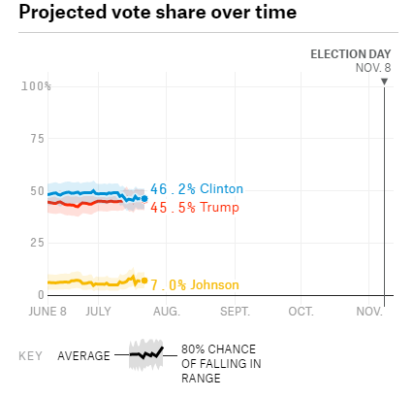
We’ve collected 26 polls in Florida so far. The model weights each poll by its sample size, how recently it was conducted, and the historical accuracy and methodology of the polling firm. The model then adjusts each poll based on other factors.

Iowa

She’s only ahead by .4 points in Iowa (6 electoral votes)
Silver 7/15/16 (Nate Silver is the founder and editor in chief of FiveThirtyEight; this poll considers the 12 most recent polls up to the last one from July 15; Now-cast is a projection of what would happen in a hypothetical election held today; “Who Will Win Iowa?”; http://projects.fivethirtyeight.com/2016-election-forecast/iowa/#now)//hbuz
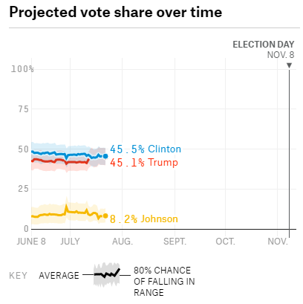
***The now-cast takes the weighted, adjusted polling average for each state, heavily emphasizing recent polls, and uses demographic data to help model the outcome in states with little polling. It then projects what would happen if the election were held today. Because uncertainty decreases as the election approaches, the now-cast has more statistical confidence than our other models. Both likely voter polls and registered voter polls are included in the election models (few polls also include voters and all adults).

We’ve collected 12 polls in Iowa so far. The model weights each poll by its sample size, how recently it was conducted, and the historical accuracy and methodology of the polling firm. The model then adjusts each poll based on other factors.

Michigan

She’s 5.4 points ahead in Michigan (16 electoral votes)
Silver 7/15/16 (Nate Silver is the founder and editor in chief of FiveThirtyEight; this poll considers the 11 most recent polls up to the last one from July 15; Now-cast is a projection of what would happen in a hypothetical election held today; “Who Will Win Michigan?”; http://projects.fivethirtyeight.com/2016-election-forecast/michigan/#now)//hbuz
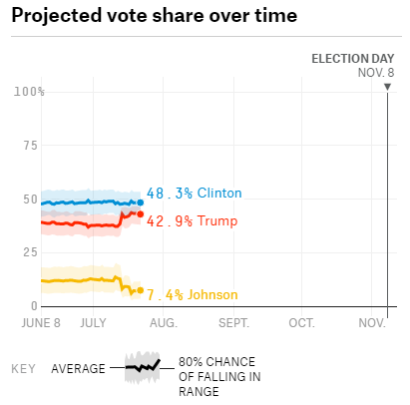
***The now-cast takes the weighted, adjusted polling average for each state, heavily emphasizing recent polls, and uses demographic data to help model the outcome in states with little polling. It then projects what would happen if the election were held today. Because uncertainty decreases as the election approaches, the now-cast has more statistical confidence than our other models. Both likely voter polls and registered voter polls are included in the election models (few polls also include voters and all adults).

We’ve collected 11 polls in Michigan so far. The model weights each poll by its sample size, how recently it was conducted, and the historical accuracy and methodology of the polling firm. The model then adjusts each poll based on other factors.

Nevada

She’s ahead by 1.7 points in Nevada (6 electoral votes)
Silver 7/10/16 (Nate Silver is the founder and editor in chief of FiveThirtyEight; this poll considers the five most recent polls up to the last one from July 10; Now-cast is a projection of what would happen in a hypothetical election held today; “Who Will Win Nevada?”; http://projects.fivethirtyeight.com/2016-election-forecast/nevada/#now)//hbuz
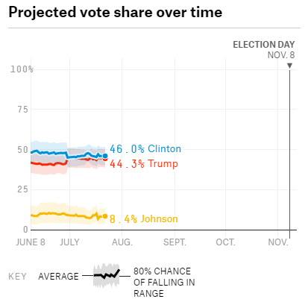
***The now-cast takes the weighted, adjusted polling average for each state, heavily emphasizing recent polls, and uses demographic data to help model the outcome in states with little polling. It then projects what would happen if the election were held today. Because uncertainty decreases as the election approaches, the now-cast has more statistical confidence than our other models. Both likely voter polls and registered voter polls are included in the election models (few polls also include voters and all adults).

We’ve collected five polls in Nevada so far. The model weights each poll by its sample size, how recently it was conducted, and the historical accuracy and methodology of the polling firm. The model then adjusts each poll based on other factors.

New Hampshire

She’s ahead by .3 points in New Hampshire (4 electoral votes)
Silver 7/18/16 (Nate Silver is the founder and editor in chief of FiveThirtyEight; this poll considers the 20 most recent polls up to the last one from July 18; Now-cast is a projection of what would happen in a hypothetical election held today; “Who Will Win New Hampshire?”; http://projects.fivethirtyeight.com/2016-election-forecast/new-hampshire/#now)//hbuz
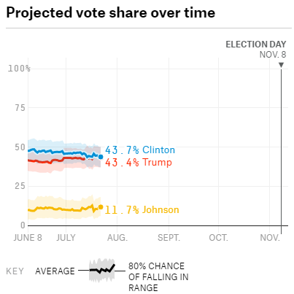
***The now-cast takes the weighted, adjusted polling average for each state, heavily emphasizing recent polls, and uses demographic data to help model the outcome in states with little polling. It then projects what would happen if the election were held today. Because uncertainty decreases as the election approaches, the now-cast has more statistical confidence than our other models. Both likely voter polls and registered voter polls are included in the election models (few polls also include voters and all adults).

We’ve collected 20 polls in New Hampshire so far. The model weights each poll by its sample size, how recently it was conducted, and the historical accuracy and methodology of the polling firm. The model then adjusts each poll based on other factors.

North Carolina

She’s ahead by .6 points in North Carolina (15 electoral votes)
Silver 7/11/16 (Nate Silver is the founder and editor in chief of FiveThirtyEight; this poll considers the 19 most recent polls up to the last one from July 11; Now-cast is a projection of what would happen in a hypothetical election held today; “Who Will Win North Carolina?”; http://projects.fivethirtyeight.com/2016-election-forecast/north-carolina/#now)//hbuz
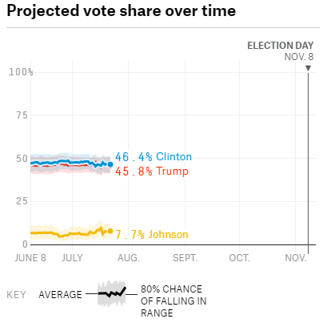
***The now-cast takes the weighted, adjusted polling average for each state, heavily emphasizing recent polls, and uses demographic data to help model the outcome in states with little polling. It then projects what would happen if the election were held today. Because uncertainty decreases as the election approaches, the now-cast has more statistical confidence than our other models. Both likely voter polls and registered voter polls are included in the election models (few polls also include voters and all adults).

We’ve collected 19 polls in North Carolina so far. The model weights each poll by its sample size, how recently it was conducted, and the historical accuracy and methodology of the polling firm. The model then adjusts each poll based on other factors.

Ohio

She’s ahead by 1.7 points in Ohio (18 electoral votes)
Silver 7/20/16 (Nate Silver is the founder and editor in chief of FiveThirtyEight; this poll considers the 20 most recent polls up to the last one from July 20; Now-cast is a projection of what would happen in a hypothetical election held today; “Who Will Win Ohio?”; http://projects.fivethirtyeight.com/2016-election-forecast/ohio/#now)//hbuz
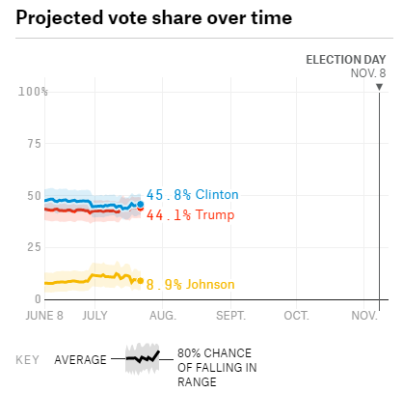
***The now-cast takes the weighted, adjusted polling average for each state, heavily emphasizing recent polls, and uses demographic data to help model the outcome in states with little polling. It then projects what would happen if the election were held today. Because uncertainty decreases as the election approaches, the now-cast has more statistical confidence than our other models. Both likely voter polls and registered voter polls are included in the election models (few polls also include voters and all adults).

We’ve collected 20 polls in Ohio so far. The model weights each poll by its sample size, how recently it was conducted, and the historical accuracy and methodology of the polling firm. The model then adjusts each poll based on other factors.

Pennsylvania

She’s ahead by 1.8 points in Pennsylvania (20 electoral votes)
Silver 7/11/16 (Nate Silver is the founder and editor in chief of FiveThirtyEight; this poll considers the 16 most recent polls up to the last one from July 11; Now-cast is a projection of what would happen in a hypothetical election held today; “Who Will Win Pennsylvania?”; http://projects.fivethirtyeight.com/2016-election-forecast/pennsylvania/#now)//hbuz
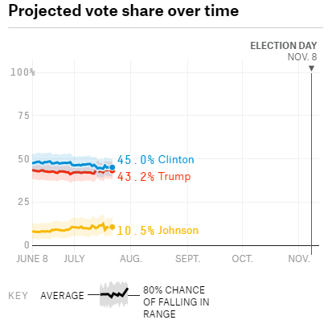
***The now-cast takes the weighted, adjusted polling average for each state, heavily emphasizing recent polls, and uses demographic data to help model the outcome in states with little polling. It then projects what would happen if the election were held today. Because uncertainty decreases as the election approaches, the now-cast has more statistical confidence than our other models. Both likely voter polls and registered voter polls are included in the election models (few polls also include voters and all adults).

We’ve collected 16 polls in Pennsylvania so far. The model weights each poll by its sample size, how recently it was conducted, and the historical accuracy and methodology of the polling firm. The model then adjusts each poll based on other factors.

Virginia

She’s ahead by 3.3 points in Virginia (13 electoral votes)
Silver 7/11/16 (Nate Silver is the founder and editor in chief of FiveThirtyEight; this poll considers the 11 most recent polls up to the last one from July 11; Now-cast is a projection of what would happen in a hypothetical election held today; “Who Will Win Pennsylvania?”; http://projects.fivethirtyeight.com/2016-election-forecast/virginia/#now)//hbuz
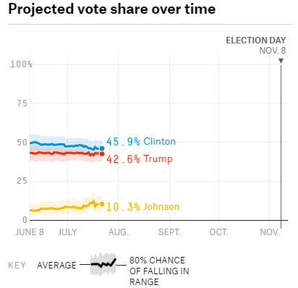
***The now-cast takes the weighted, adjusted polling average for each state, heavily emphasizing recent polls, and uses demographic data to help model the outcome in states with little polling. It then projects what would happen if the election were held today. Because uncertainty decreases as the election approaches, the now-cast has more statistical confidence than our other models. Both likely voter polls and registered voter polls are included in the election models (few polls also include voters and all adults).

We’ve collected 11 polls in Virginia so far. The model weights each poll by its sample size, how recently it was conducted, and the historical accuracy and methodology of the polling firm. The model then adjusts each poll based on other factors.

Wisconsin

She’s ahead by 4.8 in Wisconsin (10 electoral votes)
Silver 7/10/16 (Nate Silver is the founder and editor in chief of FiveThirtyEight; this poll considers the 15 most recent polls up to the last one from July 10; Now-cast is a projection of what would happen in a hypothetical election held today; “Who Will Win Pennsylvania?”; http://projects.fivethirtyeight.com/2016-election-forecast/wisconsin/#now)//hbuz
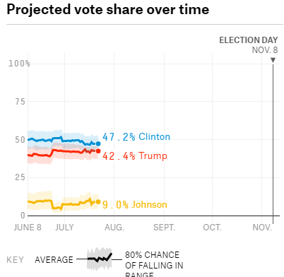
***The now-cast takes the weighted, adjusted polling average for each state, heavily emphasizing recent polls, and uses demographic data to help model the outcome in states with little polling. It then projects what would happen if the election were held today. Because uncertainty decreases as the election approaches, the now-cast has more statistical confidence than our other models. Both likely voter polls and registered voter polls are included in the election models (few polls also include voters and all adults).

We’ve collected 15 polls in Wisconsin so far. The model weights each poll by its sample size, how recently it was conducted, and the historical accuracy and methodology of the polling firm. The model then adjusts each poll based on other factors.

Job Loss

Job loss swings the election towards a Trump Victory – The status of the economy is very pertinent for voters
Silver 7/15/16
(Nate, Founder and Editor in Chief of FiveThirtyEight, “Election Update: 10 Questions About Where the 2016 Race Stands” http://fivethirtyeight.com/features/election-update-10-questions-about-where-the-2016-race-stands/ - KSA)
By fundamentals, I mean factors apart from head-to-head polls that potentially have predictive power, such as economic conditions, incumbency and presidential approval ratings. We’ve long had a love-hate relationship with the “fundamentals” at FiveThirtyEight. In theory, they help us to understand why voters act as they do (a better economy encourages them to reward the incumbent party, for example). But in practice, models that have attempted to predict the election without looking at polls have a middling-to-poor track record. So we’ve decided to compromise by issuing both a polls-only model and a polls-plus model, which blends polls with an economic index. Right now, the economic index gets about 35 percent of the weight in polls-plus; it will decline to zero by Election Day. The economic index implies that the race should be close. But stronger economic data lately — in particular, a good jobs report this month — shows an economy that is very slightly above average. That translates into a very narrow advantage, about 1 or 2 percentage points, for Clinton. Obama’s approval ratings — not a factor our models use, but useful for context — are also very slightly above average, which could help Clinton at the margin.

﻿

National Security = Trump Win

Trump posited himself as strong on security at the RNC – voters will run to him if they feel national security is threatened
Healy and Martin 7/21/16 (Patrick, journalist for the New York Times, Jonathan, national political correspondent for The New York Times, senior political writer for Politico, Covered politics for National Journal’s political publication, The Hotline, reported on party politics and the aftermath of the 2006 midterm elections for National Review magazine, co-author of the New York Times best seller “The End of the Line: Romney vs. Obama: The 34 Days That Decided the Election” published in The New Republic, National Journal, The Washington Post and The Wall Street Journal, a political analyst and commentator, on CNN, ABC, CBS, NBC, PBS, MSNBC and NPR., graduate from Hampden-Sydney College. “His Tone Dark, Donald Trump takes G.O.P. Mantle” http://www.nytimes.com/2016/07/22/us/politics/donald-trump-rnc-speech.html?_r=0 - KSA)
CLEVELAND — Donald John Trump accepted the Republican presidential nomination on Thursday night with an unusually vehement appeal to Americans who feel that their country is spiraling out of control and yearn for a leader who will take aggressive, even extreme, actions to protect them. Mr. Trump, 70, a New York real estate developer and reality television star who leveraged his fame and forceful persona to become the rare political outsider to lead the ticket of a major party, drew exuberant cheers from Republican convention delegates as he strode onto the stage of the Quicken Loans Arena and delivered a speech as fiery as his candidacy. With dark imagery and an almost angry tone, Mr. Trump portrayed the United States as a diminished and even humiliated nation, and offered himself as an all-powerful savior who could resurrect the country’s standing in the eyes of both enemies and law-abiding Americans. “Our convention occurs at a moment of crisis for our nation,” an ominous-sounding Mr. Trump said, standing against a backdrop of American flags. “The attacks on our police, and the terrorism in our cities, threaten our very way of life. Any politician who does not grasp this danger is not fit to lead our country.” Mr. Trump nearly shouted the names of states where police officers had been killed recently, as the crowd erupted in applause, and returned repeatedly to the major theme of the speech: “Law and order,” he said four times, each time drawing out the syllables. Evoking the tumult of the 1960s and the uncertainty that followed the Sept. 11 terrorist attacks, Mr. Trump made a sharp departure from the optimistic talk about American possibility that has characterized Republican presidential candidates since Ronald Reagan redefined the party over 30 years ago. In promoting his hard-line views on crime, immigration and hostile nations, Mr. Trump was wagering that voters would embrace his style of populism and his promises of safety if they feel even less secure by Election Day.

